Tabari Harvey Module 1.2 Assignment

1. https://github.com/MurphT4stic/csd-310
2. 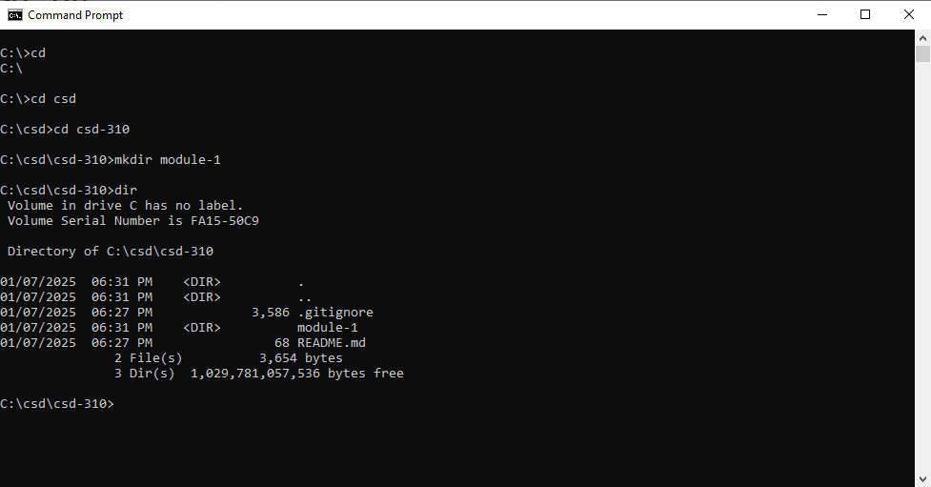 Module 1